selectESTRUCTURA BASE DE DATOS HOSPITAL

RELACIONES ENTRE TABLAS

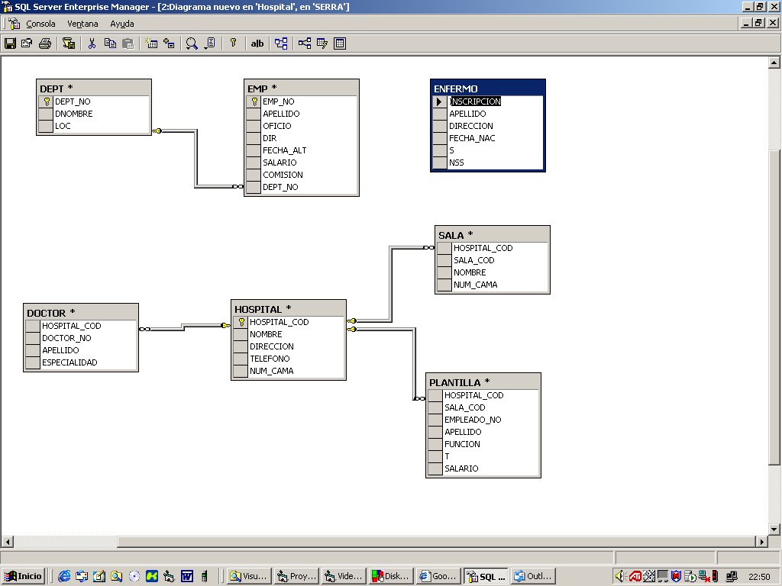TIPOS DE DATOS DE LAS COLUMNAS

## EMP

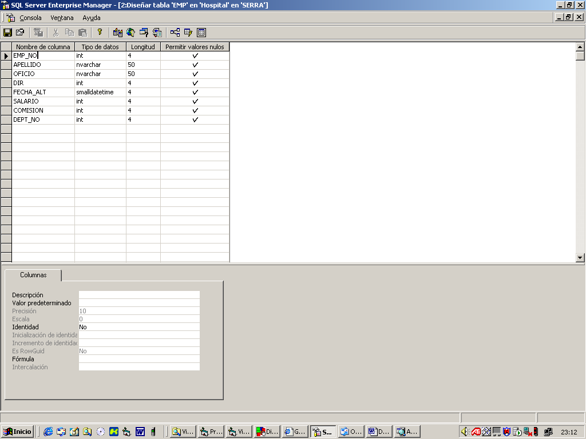

## DEPT

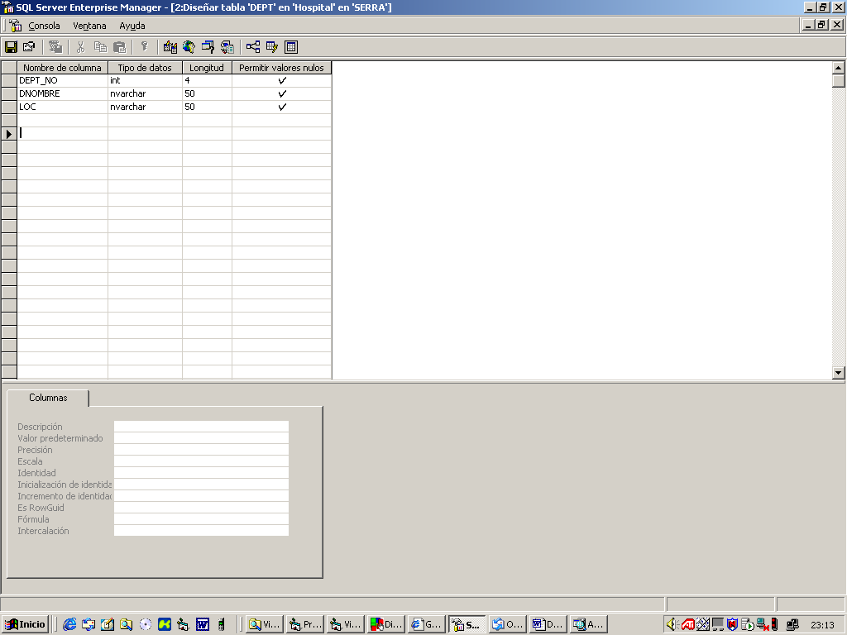

# HOSPITAL

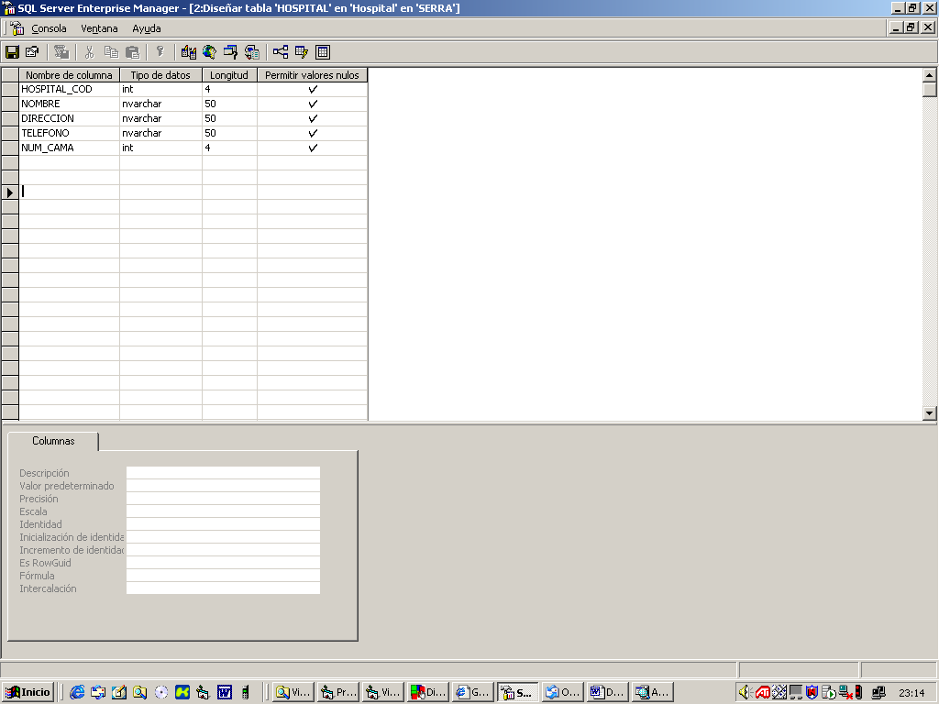

# DOCTOR

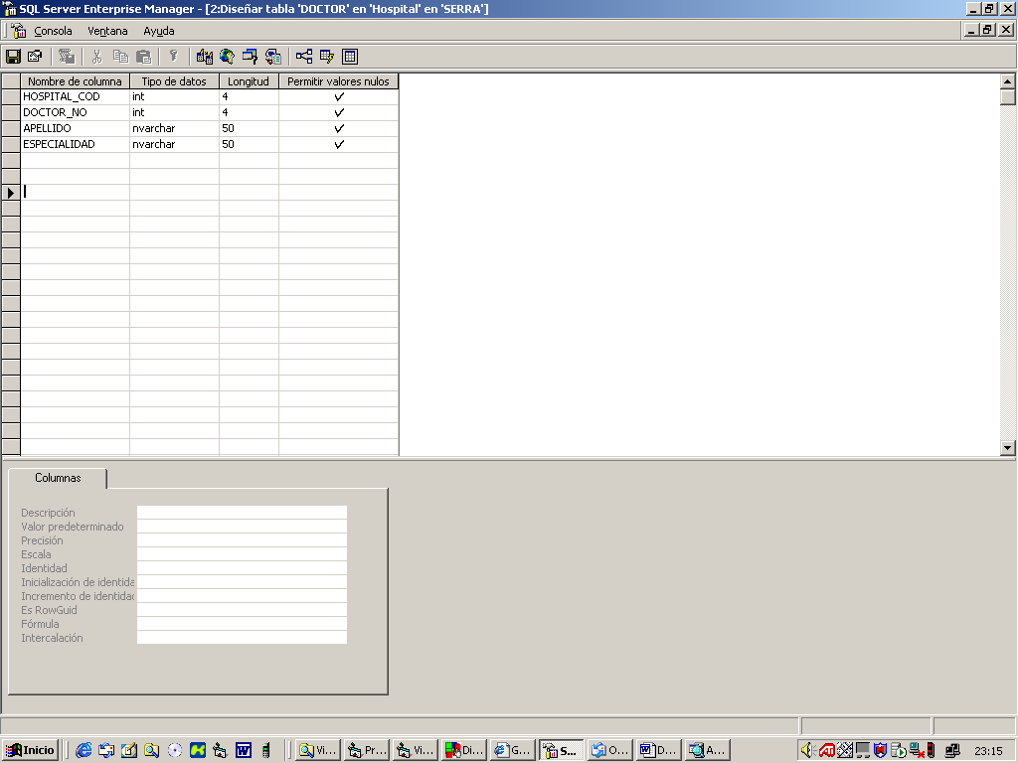

# PLANTILLA

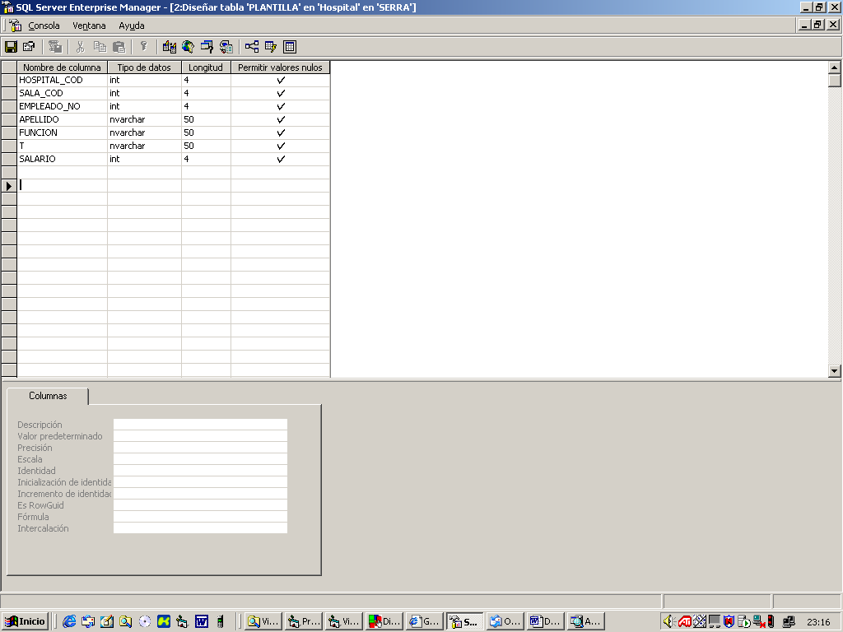

# SALA

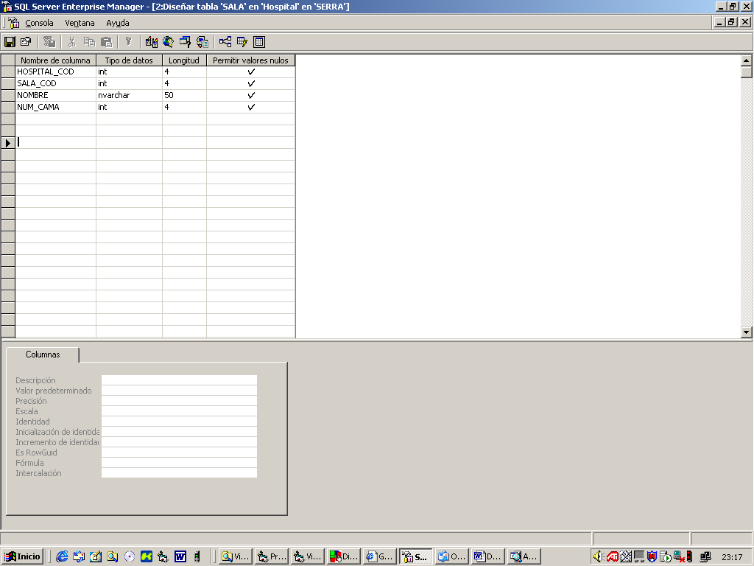

# ENFERMO

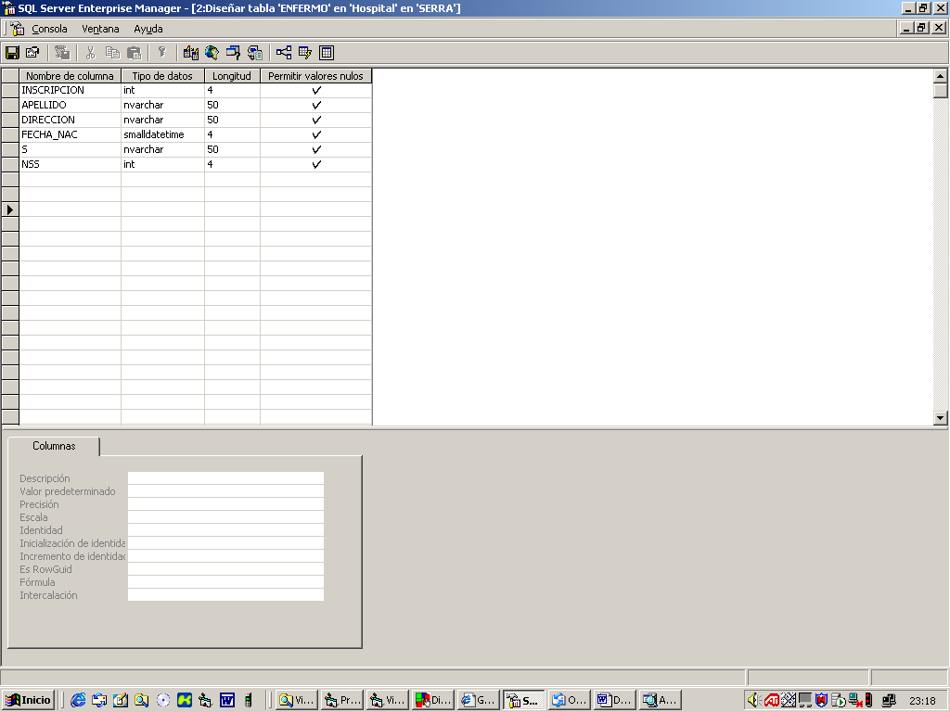

# DATOS DE LA TABLA EMP

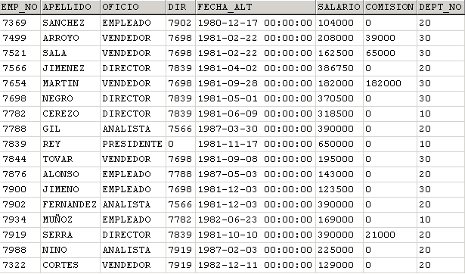

# DATOS DE LA TABLA DEPT

|  |  |  |
| --- | --- | --- |
| **DEPT_NO** | **DNOMBRE** | **LOC** |
| 10 | CONTABILIDAD | ELCHE |
| 20 | INVESTIGACION | MADRID |
| 30 | VENTAS | BARCELONA |
| 40 | PRODUCCION | SALAMANCA |

# DATOS DE LA TABLA HOSPITAL

|  |  |  |  |  |
| --- | --- | --- | --- | --- |
| **HOSPITAL_COD** | **NOMBRE** | **DIRECCION** | **TELEFONO** | **NUM_CAMA** |
| 19 | Provincial | O' Donell 50 | 964-4256 | 502 |
| 18 | General | Atocha s/n | 595-3111 | 987 |
| 22 | La Paz | Castellana 1000 | 923-5411 | 412 |
| 45 | San Carlos | Ciudad Universitaria | 597-1500 | 845 |

# DATOS DE LA TABLA DOCTOR

|  |  |  |  |
| --- | --- | --- | --- |
| **HOSPITAL_COD** | **DOCTOR_NO** | **APELLIDO** | **ESPECIALIDAD** |
| 22 | 386 | Cabeza D. | Psiquiatría |
| 22 | 398 | Best D. | Urología |
| 19 | 435 | López A. | Cardiología |
| 22 | 453 | Galo D. | Pediatría |
| 45 | 522 | Adams C. | Neurología |
| 18 | 585 | Miller G. | Ginecología |
| 45 | 607 | Chuki P. | Pediatría |
| 18 | 982 | Cajal R. | Cardiología |

# DATOS DE LA TABLA PLANTILLA

|  |  |  |  |  |  |  |
| --- | --- | --- | --- | --- | --- | --- |
| **HOSPITAL_COD** | **SALA_COD** | **EMPLEADO_NO** | **APELLIDO** | **FUNCION** | **T** | **SALARIO** |
| 22 | 6 | 1009 | Higueras D. | Enfermera | T | 200500 |
| 45 | 4 | 1280 | Amigo R. | Interino | N | 221000 |
| 19 | 6 | 3106 | Hernández J. | Enfermero | T | 275000 |
| 19 | 6 | 3754 | Díaz B. | Enfermera | T | 226200 |
| 22 | 1 | 6065 | Rivera G. | Enfermera | N | 162600 |
| 18 | 4 | 6357 | Karplus W. | Interino | T | 337900 |
| 22 | 1 | 7379 | Carlos R. | Enfermera | T | 211900 |
| 22 | 6 | 8422 | Bocina G. | Enfermero | M | 183800 |
| 45 | 1 | 8526 | Frank H. | Enfermera | T | 252200 |
| 22 | 2 | 9901 | Núñez C. | Interino | M | 221000 |

# DATOS DE LA TABLA ENFERMO

|  |  |  |  |  |  |
| --- | --- | --- | --- | --- | --- |
| **INSCRIPCION** | **APELLIDO** | **DIRECCION** | **FECHA_NAC** | **S** | **NSS** |
| 10995 | Laguía M. | Goya 20 | 16-may-56 | M | 280862422 |
| 14024 | Fernández M. | Recoletos 50 | 21-may-60 | F | 284991452 |
| 18004 | Serrano V. | Alcalá 12 | 23-jun-67 | F | 321790059 |
| 36658 | Domin S. | Mayor 71 | 01-ene-42 | M | 160654471 |
| 38702 | Neal R. | Orense 11 | 18-jun-40 | F | 380010217 |
| 39217 | Cervantes M. | Perón 38 | 29-feb-52 | M | 440294390 |
| 59076 | Miller B. | López de Hoyos 2 | 16-sep-45 | F | 311969044 |
| 63827 | Ruiz P. | Ezquerdo 103 | 26-dic-80 | M | 100973253 |
| 64823 | Fraiser A. | Soto 3 | 10-jul-80 | F | 285201776 |
| 74835 | Benítez E. | Argentina | 05-oct-57 | M | 154811767 |

# DATOS DE LA TABLA SALA

|  |  |  |  |
| --- | --- | --- | --- |
| **HOSPITAL_COD** | **SALA_COD** | **NOMBRE** | **NUM_CAMA** |
| 22 | 1 | Recuperación | 10 |
| 45 | 1 | Recuperación | 15 |
| 22 | 2 | Maternidad | 34 |
| 45 | 2 | Maternidad | 24 |
| 19 | 3 | Cuidados Intensivos | 21 |
| 18 | 3 | Cuidados Intensivos | 10 |
| 18 | 4 | Cardiología | 53 |
| 45 | 4 | Cardiología | 55 |
| 19 | 6 | Psiquiátricos | 67 |
| 22 | 6 | Psiquiátricos | 118 |